**Week 6 – LAB 4**

**1.First question:**

Write a java program that asks the user to enter two positive numbers. If the user enters a negative number, then the program keeps asking him\her to renter a positive one. Finally, the program prints the sum of the two numbers.

**Typical run of the program**

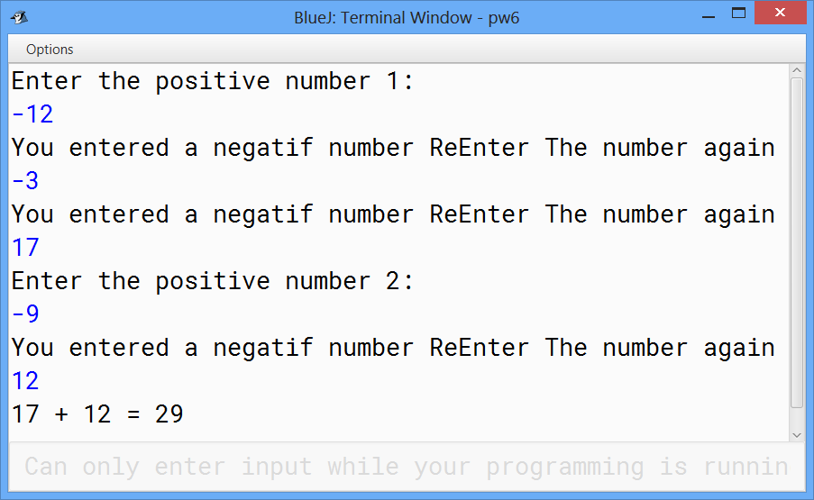

**2.Second question:**

Write a java program that asks the user to enter his\her grade. The grade must be between 0 and 100, and then print if the user succeed or fail. To succeed the grade must be greater than 60.

**Typical run of the program**

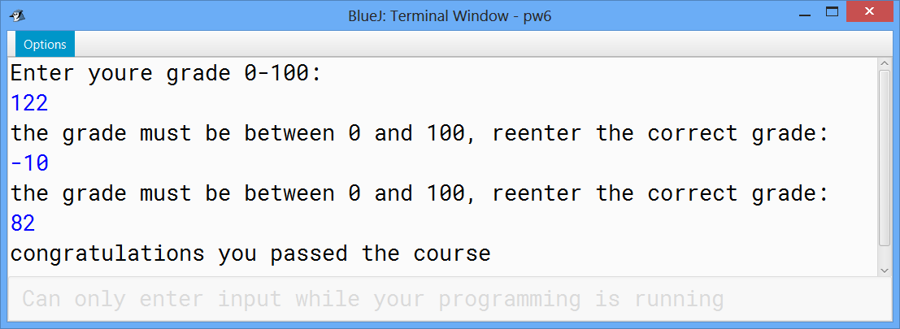

**3.Third question:**

Write a java program, using the while loop, that:

* Ask the user to give a positive number less than 100.
* Print all the numbers from the given number to 200.

**Typical run of the program**

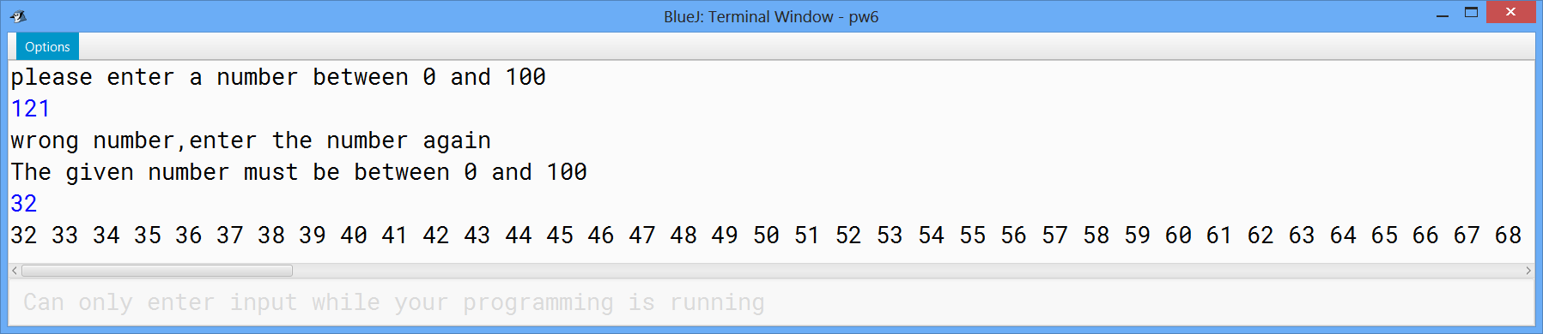

**4.Fourth question:**

Write a java program that asks the user to enter a number between 50 and 100 then print all the multiple of 5 from zero to the given number.

**Typical run of the program**

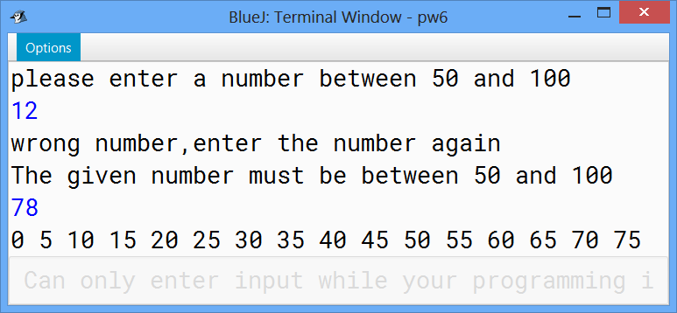

**5. Fifth question:**

 Write a java program that act as a simple calculator using the switch statement.

**Typical run of the program**

